TC-CMS-026
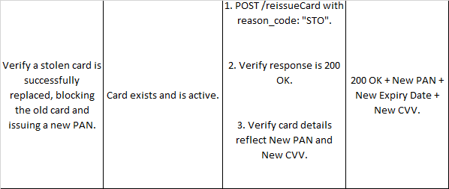
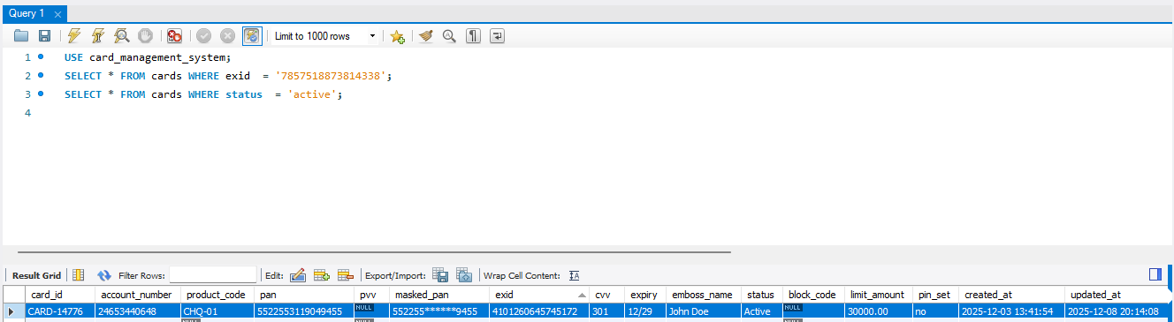
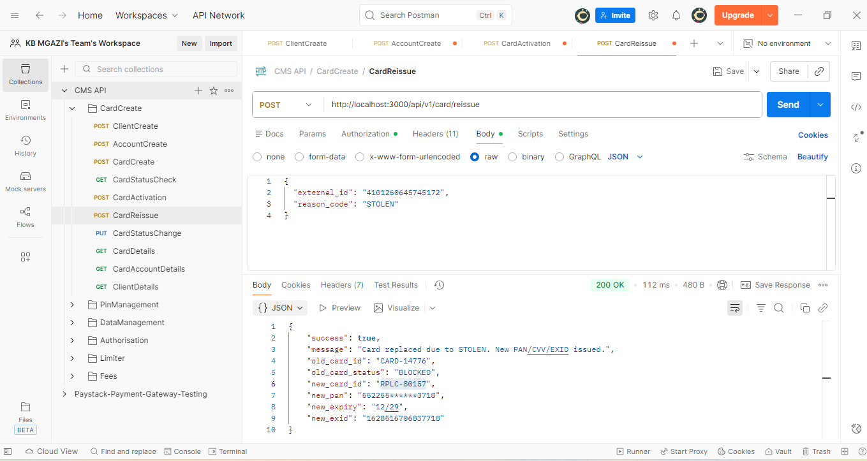
Request:
{
"external_id": "4101260645745172",
"reason_code": "STOLEN"
}

Response:
{
"success": true,
"message": "Card replaced due to STOLEN. New PAN/CVV/EXID issued.",
"old_card_id": "CARD-14776",
"old_card_status": "BLOCKED",
"new_card_id": "RPLC-80157",
"new_pan": "552255******3718",
"new_expiry": "12/29",
"new_exid": "1628516706837718"
}

